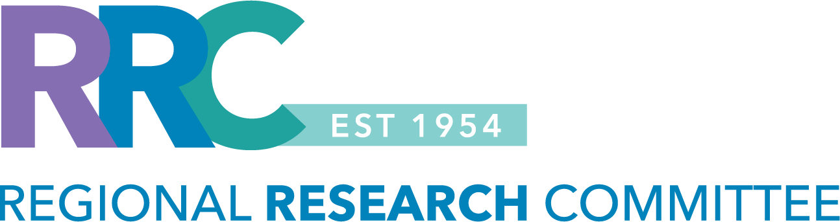

RRC TRADITIONAL GRANT
Letter of Intent (Fall 2026)

Instructions for Preparing Your Letter of Intent: Please use the template below to prepare your Letter of Intent (LOI). The LOI must be limited to one page, using 11-point font and 0.5-inch margins. The one-page limit does not include any required supporting documentation. Before submitting your LOI, please delete all instructions shown in red font. All sections shown in black font must be completed.

- Please review information about the RRC’s eligibility criteria and funding guidelines to ensure the project is eligible for internal funding. Clinical trials are not eligible for RRC funding.
- The funding cycle for this grant is January 1, 2027 – December 31, 2027.
- The award duration is one year, with a budget of up to $55,000 in research support.
  - The funds can be used for data extraction, statistical analysis, and project support.
- Projects that do not meet eligibility criteria will not be considered.
- Refer to the RRC website for more information or to access the RRC’s 2026 proposal submission calendar.

LOI submission deadline: Monday, August 10, 2026, at 11:59PM (PST).
- Send the LOI submission to: Regional-Research-Committee@kp.org

PRINCIPAL INVESTIGATOR (PI): [insert name, department, medical center]
- Please list only one Principal Investigator. The PI must be willing to assume responsibility for the management of the research, while also complying with the financial and administrative policies, research compliance and human subject protection regulations associated with the research project. Please review the RRC’s eligibility criteria to determine who can be a principal investigator.

KPSC CO-INVESTIGATOR(S): [insert name, department, medical center]
- Please review the RRC’s eligibility criteria to determine who can be a KPSC co-investigator.

STUDY TITLE: [insert study title]

Study Type (Select all that apply):
☐ Data review ☐ Observational study (i.e., prospective, recruitment, on-line survey administration)

1.0 BACKGROUND AND SIGNIFICANCE: Provide a paragraph summary of the background and significance of your research idea. The background should succinctly describe the current state of knowledge and identify the problem to be addressed.

2.0 RESEARCH QUESTION / HYPOTHESIS: Clearly state the research question or hypothesis that will be addressed in the proposed study. For guidance with developing a research question, refer to: 1A. Identifying a Research Question

3.0 STUDY AIM(S): Provide the study aim(s) that will be addressed in the proposed study. Please provide a brief description of the proposed methods e.g., retrospective vs. prospective, case-control, cohort, cross-sectional study design and a description of the main variables that will be measured. For guidance with developing a study plan, refer to: 1B. Developing a Study Plan

4.0 CLINICAL IMPLICATIONS / IMPACT: Provide a statement of the potential clinical implications or operational impact of the proposed study. Please be as specific as possible.

5.0 SUPPORTING DOCUMENTATION: Please review the categories listed below and provide a response, including supporting documentation if required.

Category #1: Previous Regional Research Committee Funding: ☐ Yes ☐ No
- If you have received RRC funding in the past, provide the RRC grant number and a summary of your previous work (presentations / publications) on a separate page.
- You must provide a summary for each project that was funded by the RRC.

Category #2: Institutional Review Board (IRB) Approved Study: ☐ Yes ☐ No ☐ Pending approval
- Please do not submit a research application for IRB approval before the RRC makes a funding decision.
- If you are awarded funding, the Regional Research Committee staff will obtain IRB approval of your study via a streamlined process.

- If your study is already IRB approved, please provide:
  - the IRB approval number,
  - copy of the IRB approved research application and data abstraction sheet,
  - summary of the work that has already been completed,
  - state why you are seeking RRC funding, and
  - the Virtual Research Office help desk ticket number if your study has received programming / analytical support via the Small Targeted Analysis Research (STAR) Program.

- If you submitted a research application to the IRB office and the approval is pending, please provide the iRIS reference number for your research application submission.

Category #3: Graduate Medical Education (GME) Involvement: ☐ Yes ☐ No
- If significant KPSC resident or fellow involvement is anticipated, please provide a detailed mentorship plan.
- Residents, fellows, or medical students from external institutions are not eligible to participate in this grant.

- The detailed mentorship plan should include:
- names of the KPSC trainees to be involved, PGY-level, KPSC GME program affiliation, department, and medical center
- goals and objectives for the trainees
- mentor / mentee roles and responsibilities,
- expectations for the trainees (meeting frequency and format / location), and
- plans for creating a research environment for the trainees.

Before submitting your LOI, please ensure that all required sections are completed and that any applicable supporting documentation is included. If you have questions or need assistance, please contact the RRC staff at Regional-Research-Committee@kp.org

Letter of Intent (LOI) Submission Checklist
Applicant checklist to review before submitting your LOI

Before submitting your LOI, please confirm that each item below has been completed. The one-page LOI limit excludes any required supporting documentation.

Done | Checklist Item
☐ | The LOI uses the required template.
☐ | The LOI is limited to one page, excluding any required supporting documentation.
☐ | The LOI uses 11-point font and 0.5-inch margins.
☐ | All sections shown in black font have been completed.
☐ | All instructions shown in red font have been removed.
☐ | Any required supporting documentation has been included.
☐ | The proposed project aligns with the goals and eligibility requirements of the funding opportunity.
☐ | The Principal Investigator and key co-investigators have reviewed the LOI.
☐ | The LOI is being submitted by the stated deadline.

If you have questions or need assistance, please contact the RRC staff at Regional-Research-Committee@kp.org

Letter of Intent (LOI) Frequently Asked Questions (FAQ)
Brief guidance for common LOI questions

This FAQ is intended to help applicants prepare a complete LOI and understand common submission expectations. Please refer to the funding announcement for opportunity-specific requirements.

1. Who is eligible to apply?
SCPMG partners or full-time associate physicians or full-time Kaiser Permanente Southern California employees can apply for this grant and serve as the principal investigator in the study.

2. Do supporting documents count toward the one-page LOI limit?
No. The one-page limit applies only to the letter of intent. Any required supporting documentation is excluded from the page limit.

3. Can I modify the LOI template?
No. Applicants should use the provided template and complete all required sections. Instructions shown in red font should be removed before submission.

4. Can I submit more than one LOI?
Applicants are strongly encouraged to submit only one letter of intent. Under RRC funding guidelines, an investigator or team of investigators may not have more than one study funded by the RRC during the same funding cycle or during overlapping funding cycles. Submitting a single LOI helps ensure alignment with these funding restrictions.

5. What if I am unsure whether my project fits the funding opportunity?
Applicants are encouraged to contact the RRC staff before submission to discuss eligibility and project fit.

6. Can co-investigators be included?
Yes. Please identify any KPSC co-investigators in your LOI as outlined in the LOI template and follow any additional guidance provided in the funding announcement.

The following eligibility requirements apply:
- External co-investigators are not eligible to serve as co-investigators on an RRC-funded project.
- External medical students, residents, and fellows, including those completing a clinical rotation within KPSC, are also not eligible to serve as co-investigators.
- Additional information about the RRC’s eligibility criteria can be found HERE

7. What happens after I submit my LOI?
Submitted LOIs will be reviewed for eligibility and responsiveness to the funding opportunity. Applicants selected to advance to the next stage will be invited to submit a full proposal and will receive additional information, resources, and guidance to support proposal development and submission.

8. Who should I contact if I have questions?
If you have questions or need assistance, please contact the RRC staff at
Regional-Research-Committee@kp.org

