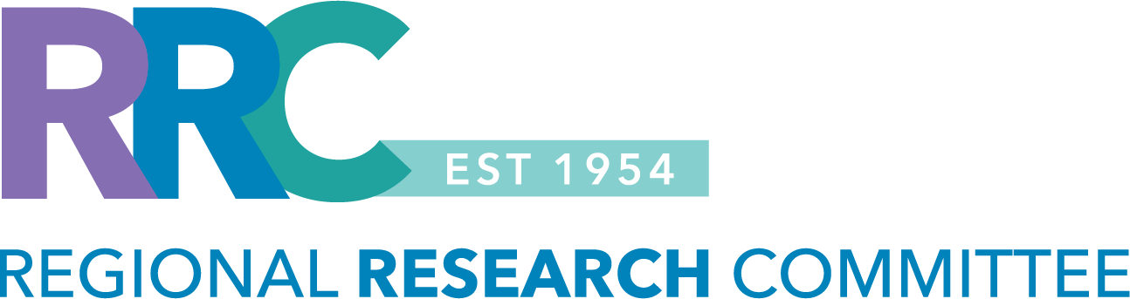

RRC Proposal Submission Calendar – 2026

Stage | Spring 2026  Traditional Grant  Funding Cycle: July 1, 2026 – June 30, 2027 | Fall 2026  Traditional Grant  Funding Cycle: January 1 – December 31, 2027
Letter of Intent Due | Friday, February 27, 2026  Deadline: 11:59 PM (PST) | Monday, Aug 10, 2026  Deadline: 11:59 PM (PST)
Proposal Development | February 27 – March 27, 2026 | Aug 10 – Sep 8, 2026
Proposal Due | Friday, March 27, 2026  Deadline: 11:59 PM (PST) | Tuesday, Sep 8, 2026  Deadline: 11:59 PM (PST)
RRC Review Meeting | Thursday, May 14, 2026 | Thursday, October 22, 2026
Award Notice | Friday, June 5, 2026 | Friday, November 13, 2026
Earliest Start Date | July 1, 2026 | January 1, 2027

- You can access information about our funding opportunities and eligibility criteria at: Regional Research Committee
- For assistance send an email to: Regional-Research-Committee@kp.org

