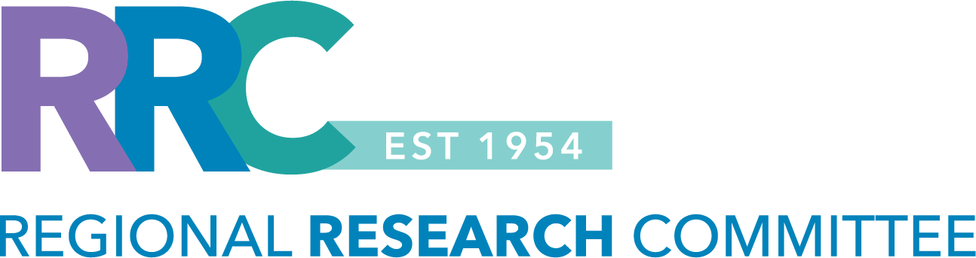

RRC TRADITIONAL GRANT
Letter of Intent (Spring 2026)

INSTRUCTIONS: Use the template below to draft your Letter of Intent (LOI). The LOI should be one page, 11-pt. font and .5 margins. The one-page limit excludes the supporting documentation that may be required. Please delete the instructions in red font before submitting your letter of intent. All sections in black font must be completed.

- Please review information about the RRC’s eligibility criteria and funding guidelines to ensure the project is eligible for internal funding. Clinical trials are not eligible for RRC funding.
- The funding cycle for this grant is July 1, 2026 – June 30, 2027.
- The award duration is one year, with a budget of up to $55,000 in research support.
  - The funds can be used for data extraction, statistical analysis, and project support.
- Projects that do not meet eligibility criteria will not be considered.
- Refer to the RRC website for more information or to access the RRC’s 2026 proposal submission calendar.

LOI submission deadline: Friday, February 27, 2026, at 11:59PM (PST).
- Send the LOI submission to: Regional-Research-Committee@kp.org

PRINCIPAL INVESTIGATOR: [insert name, department, medical center]
- Please list only one Principal Investigator. The PI must be willing to assume responsibility for the management of the research, while also complying with the financial and administrative policies, research compliance and human subject protection regulations associated with the research project. Please review the RRC’s eligibility criteria to determine who can be a principal investigator.

KPSC CO-INVESTIGATOR(S): [insert name, department, medical center]
- Please review the RRC’s eligibility criteria to determine who can be a KPSC co-investigator.

STUDY TITLE: [insert study title]

Study Type (Select all that apply):
☐ Data review ☐ Observational study (i.e., prospective, recruitment, on-line survey administration)

1.0 BACKGROUND AND SIGNIFICANCE: Provide a paragraph summary of the background and significance of your research idea. The background should succinctly describe the current state of knowledge and identify the problem to be addressed.

2.0 RESEARCH QUESTION / HYPOTHESIS: Clearly state the research question or hypothesis that will be addressed in the proposed study. For guidance with developing a research question, refer to: 1A. Identifying a Research Question

3.0 STUDY AIM(S): Provide the study aim(s) that will be addressed in the proposed study. Please provide a brief description of the proposed methods e.g., retrospective vs. prospective, case-control, cohort, cross-sectional study design and a description of the main variables that will be measured. For guidance with developing a study plan, refer to: 1B. Developing a Study Plan

4.0 CLINICAL IMPLICATIONS / IMPACT: Provide a statement of the potential clinical implications or operational impact of the proposed study. Please be as specific as possible.

5.0 SUPPORTING DOCUMENTATION: Please review the categories listed below and provide a response. If applicable, please provide the supporting documentation.

Category #1: Previous Regional Research Committee Funding: ☐ Yes ☐ No
- If you have received RRC funding in the past, provide the RRC grant number and a summary of your previous work (presentations / publications) on a separate page.
- You must provide a summary for each project that was funded by the RRC.

Category #2: Institutional Review Board (IRB) Approved Study: ☐ Yes ☐ No ☐ Pending approval
- Please do not submit a research application for IRB approval before the RRC makes a funding decision.
- If you are awarded funding, the Regional Research Committee staff will obtain IRB approval of your study via a streamlined process.

- If your study is already IRB approved, please provide:
  - the IRB approval number,
  - copy of the IRB approved research application and data abstraction sheet,
  - summary of the work that has already been completed,
  - state why you are seeking RRC funding, and
  - the Virtual Research Office help desk ticket number if your study has received programming / analytical support via the STAR Program.

- If you submitted a research application to the IRB office and the approval is pending, please provide the iRIS reference number for your research application submission.

Category #3: Graduate Medical Education (GME) Involvement: ☐ Yes ☐ No
- If significant KPSC resident or fellow involvement is anticipated, please provide a detailed mentorship plan.
  - Residents, fellows, or medical students from external institutions are not eligible to participate in this grant.

- The detailed mentorship plan should include:
- names of the KPSC trainees to be involved, PGY-level, KPSC GME program affiliation, department, and medical center
- goals and objectives for the trainees
- mentor / mentee roles and responsibilities,
- expectations for the trainees (meeting frequency and format / location), and
- plans for creating a research environment for the trainees.

Contact the RRC staff at Regional-Research-Committee@kp.org if you have questions, need help determining eligibility, or need assistance completing the letter of intent.

