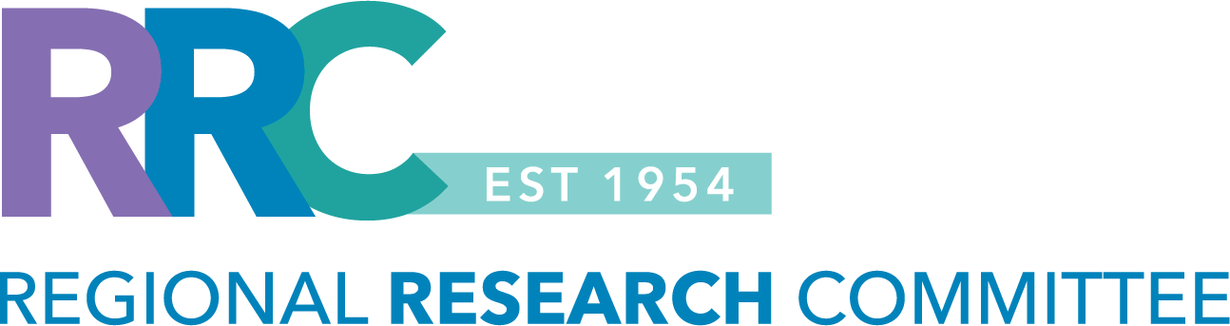

RRC-KPSOM RESEARCH PROGRAM DEVELOPMENT GRANT FOR FACULTY
Letter of Intent (Spring 2025)

This funding opportunity is intended to support a SCPMG Physician KP School of Medicine (KPSOM) faculty member who is interested in developing and leading a research program on a topic of interest with KPSOM students. Research programs are envisioned as initiatives that may start with a single study but lead to additional work through creation of sustainable research teams and/or data resources. Programs that could include multiple trainees over time are particularly welcome.

- This call for letters of intent is focused primarily on observational studies in KP populations.
  - Investigator-initiated trials or clinical trials are not eligible.
- The funding cycle for this grant is July 1, 2025 – June 30, 2026.
- The award duration is one year, with a budget of up to $75,000 in research support.
  - The funds can be used for data extraction, statistical analysis, and project support.
- Projects must be led by a SCPMG Physician who is a KPSOM faculty member and must involve KPSOM students.
  - Applicants who do not currently have a faculty appointment but wish to join the faculty can explore the process for application by contacting Dr. Jennifer Loh, MD (Interim Chair of Clinical Sciences).
- Projects that do not meet the eligibility criteria will not be considered.
- If you would like advice or consultation in designing a research program, please reach out to Stephanie Tovar, RRC Manager (Stephanie.Tovar@kp.org | 626-658-5319), or Maegan Sinclair Cortez, KPSOM Director of Research Support Services (Maegan.K.SinclairCortez@kp.org | 626-760-2529).
- Refer to the RRC website for more information or to access the RRC’s 2025 proposal submission calendar.

LOI submission deadline: Friday, February 28, 2025, at 11:59PM.
- Send the LOI submission to: Regional-Research-Committee@kp.org

INSTRUCTIONS: Use the template below to draft your Letter of Intent. The LOI should be 3-5 pages including the mentorship plan and principal investigator’s biosketch. Please use 11-pt. font and .5 margins. Please delete the instructions in red font prior to submitting your letter of intent. All sections in black font must be completed.

PRINCIPAL INVESTIGATOR: [Insert faculty name, SOM role, medical center and department]
Please list only one Principal Investigator. Only a SCPMG Physician who is (or will apply to be) a KPSOM faculty member is eligible to be a Principal Investigator for this funding opportunity. The PI must be willing to assume responsibility for the management of the research, while also complying with the financial and administrative policies, research compliance and human subject protection regulations associated with the research project.

RESEARCH PROGRAM TITLE: [Insert title for the research program]

- BACKGROUND AND SIGNIFICANCE: Provide a paragraph summary of the background and significance of the research program. The background should succinctly describe the current state of knowledge and identify the problem to be addressed. References are not required.

  - RESEARCH QUESTION / HYPOTHESIS TO BE ADDRESSED DURING GRANT PERIOD: State the main research question and/or hypothesis that will be addressed initially during the 12-month grant period.
  - STUDY DESIGN AND MAIN VARIABLES: Provide a brief description of the proposed study design, i.e., case-control, cohort, cross-sectional, and a description of the main variables that will be measured.

  - ADDITIONAL RESEARCH QUESTIONS TO BE ADDRESSED IN FUTURE STUDIES: A goal of this initiative is to develop research programs that can result in additional projects with KPSOM students over time. State one or more research question(s) that will be addressed in future studies using the data collected. Describe the proposed time frames for these studies.

2.0 KP SCHOOL OF MEDICINE TRAINEE MENTORSHIP PLAN: Applicants for these funds must involve KPSOM students in their projects as the primary trainees involved.

The detailed mentorship plan should include:
- the preferred year of student, and whether the project might serve as a student’s required Scholarly Project,
- goals and objectives for the KPSOM student,
- mentor / mentee roles and responsibilities,
- expectations for the KPSOM student (meeting frequency and format / location), and
- plans for cultivating a research environment for the KPSOM student.

Please continue to the next page to complete section 3.0 BIOSKETCH.
3.0 BIOSKETCH: The Principal Investigator must provide a one-page biosketch using the template below or
other format that includes this information. Please do not exceed the one-page limit.

BIOGRAPHICAL SKETCH

NAME |  | POSITION TITLE
EDUCATION/TRAINING (Begin with baccalaureate or other initial professional education, such as nursing, include postdoctoral training and residency training if applicable.)
INSTITUTION AND LOCATION | DEGREE  (if applicable) |  | MM/YY | FIELD OF STUDY

- Personal statement:

B. Relevant areas of research:

Please continue to the next page to complete section 4.0 SUPPORTING DOCUMENTATION.
4.0 SUPPORTING DOCUMENTATION: Please review the categories listed below. If applicable, provide the
supporting documentation.

Category #1: Previous Regional Research Committee Funding: ☐ Yes ☐ No
- If you have received RRC funding in the past, on a separate page, provide the RRC grant number and a summary of your previous work (presentations / publications).
- You must provide a summary for each project that was funded by the RRC.

Category #2: Institutional Review Board (IRB) Approved Study: ☐ Yes ☐ No ☐ Pending approval
- Please do not submit a research application for IRB approval before the RRC makes a funding decision.
- If you are awarded funding, the Regional Research Committee staff will obtain IRB approval of your study via a streamlined process.

- If your study is already IRB approved, please provide:
  - the IRB approval number,
  - copy of the IRB research application,
  - summary of the work that has already been completed, and
  - state why you are seeking RRC funding.

- If you submitted a research application to the IRB office and the approval is pending, please provide the iRIS reference number for your research application submission.

Contact the RRC Manager, Stephanie Tovar (Stephanie.Tovar@kp.org | 626-658-5319) if you have questions, need help determining eligibility, or need assistance completing the letter of intent.

